What's new in EhLib.VCL 9.3

(New features of your applications)

Brief description of new features in this version:

* Support of Lazarus under Linux

Support of Lazarus under Linux

Lazarus support for Linux has been added to the EhLib 9.3.

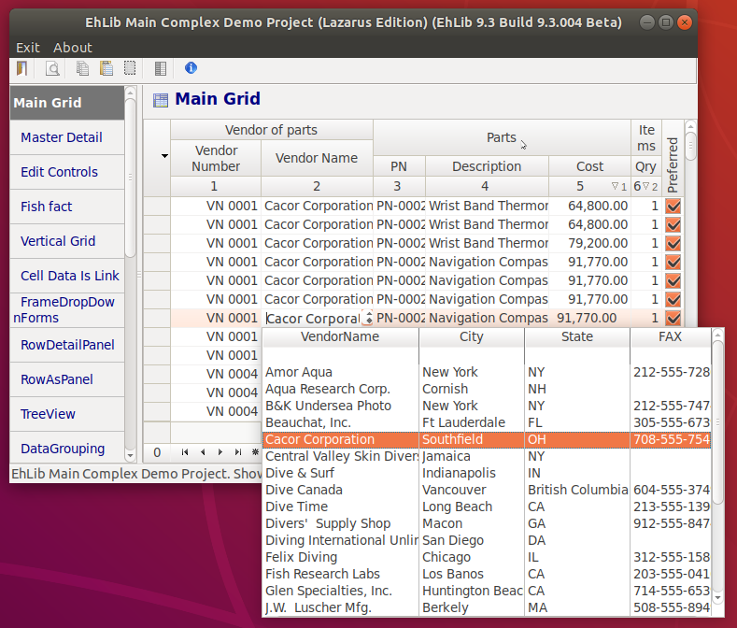

Now, when compiling the EhLib package in Lazarus, cross-platform modules of the LCL library are used.

To build and work under Linux, the library was tested using gtk2 graphical set of widgets.

Unfortunately, in this version we were unable to translate ALL the capabilities of the Delphi version of the library into the cross-platform version of the Lazarus library LCL.

In the current version there are the following limitations when running the library in cross-platform mode in Lazarus:

The TDBEditEh, TDBDateTimeEditEh, TDBNumberEditEh, TDBComboBoxEh, TDBLookupComboboxEh components do not support the EditButtons elements. In the Win32 version, EditButtons are displayed, but the text editor's cursor can go under the EditButtons elements when all text does not fit into the visible area. In GTK2, EditButtons are not displayed at all.

In the “non-cross-platform, only Win32” mode, you still have the opportunity to provide full support for EditButtons. To do this, you need to comment out the IFDEF FPC_CROSSP symbol directive of the compiler in the EhLib.Inc file and recompile the library.

TDBRichEditEh is absent in the EhLib.LCL version since the LCL does not have a Delphi compatible analogue of the TRichEdit component.

TPreviewBox is absent in the EhLib.LCL version since the LCL does not have a Delphi compatible analogue of the TMetafile class. The preview in EhLib is written based on the TMetafile class.

TPrintDBGridEh is absent in the EhLib.LCL version since the LCL does not have a Delphi compatible analogue of the TMetafile class.

When translating the library to a cross-platform version of LCL, we had to make some changes in the library regarding the inheritance and behavior of the components. These changes also affected the VCL version of the library.

* Class of DropDown window in the component TDBComboBoxEh and cell text editor in DBGridEh is now inherited from the TPopupListboxFormEh class. In the previous version it inherited from TPopupListboxEh.
* Class of DropDown window in the component TDBLookupComboBoxEh and cell text editor in DBGridEh in mode LookupComboBox now inherited from TPopupDataGridBoxEh class. In the previous version it inherited from TPopupDataGridEh.
* Class of DropDown window - Calculator is now inherited from the TPopupCalculatorFormEh class. In the previous version it inherited from TCalculatorEh.
* Class of Dropdown Calendar window is now inherited from the TPopupDateTimeCalendarFormEh class. In the previous version it inherited from TPopupDateTimeCalendarPickerEh.
* The TInplaceEdit class (grid cell text editor) is inherited from the TCustomControl class. In the previous version it inherited from TCustomMaskEdit.
* The TGridMoveLineEh class (Line when you move columns in the grid) is inherited from TGridDragFormEh class. In the previous version it inherited from TGridDragWinEh.